Ideation Phase
Define the Problem Statements

Date | 20 February 2026
Team ID | LTVIP2026TMIDS37708
Project Name | Online Payment Fraud Detection Using Machine Learning.
Maximum Marks | 2 Marks

Customer Problem Statement Template:
With the rapid growth of digital payment systems, online transactions have become increasingly vulnerable to fraud. Traditional rule-based methods are often unable to detect complex and evolving fraudulent patterns in real time, which can lead to significant financial losses and reduced user trust.
Therefore, there is a need for an intelligent and automated system that can analyze transaction data efficiently and accurately identify fraudulent activities. This project aims to develop a machine learning–based online payment fraud detection system that can learn from historical data and provide real-time predictions to help prevent fraudulent transactions.
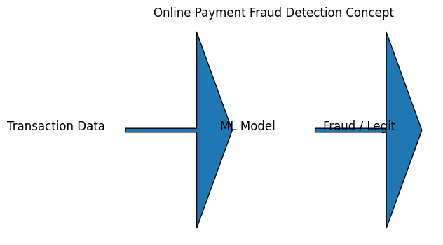
Problem Statement (PS)
PS-1
I am: Online banking customer
I’m trying to: Make secure digital payments
But: I am worried about fraudulent transactions
Because: Current systems do not always detect fraud quickly
Which makes me feel: Unsafe and concerned about financial loss

PS-2
I am: Bank fraud monitoring officer
I’m trying to: Identify fraudulent transactions efficiently
But: Manual and rule-based systems miss complex fraud patterns
Because: Fraud techniques keep evolving rapidly
Which makes me feel: Challenged to protect customer accounts effectively

Example:
Problem Statement (PS) | I am (Customer) | I’m trying to | But | Because | Which makes me feel
PS-1 | Online banking customer | Make secure digital payments | I am worried about fraudulent transactions | Current systems do not always detect fraud quickly | Unsafe and concerned about financial loss
PS-2 | Bank fraud monitoring officer | Identify fraudulent transactions efficiently | Manual and rule-based systems miss complex fraud patterns | Fraud techniques keep evolving rapidly | Challenged to protect customer accounts effectively

